**Charge and Matter**

Table of Contents

26.1 Electromagnetism – A Preview 2

26.4 Coulomb’s Law 3

26.6 Charge and Matter 4

Bubble Chamber 4

Maxwell’s Laws 5

Electromagnetic Radiation 6

Oscilloscope 7

Gauss’s Law 8

## 26.1 Electromagnetism – A Preview

Light is electromagnetic. Its speed can be found making purely electric and magnetic measurements.

## 26.4 Coulomb’s Law

Coulomb’s Law – $F=\frac{1}{4πϵ_{0}}×\frac{e^{2}}{r^{2}}$

## 26.6 Charge and Matter

$$m_{p}=1.66×{10}^{-27} kg$$

$$m_{e}=9.10×{10}^{-31} kg$$

$$e=1.66×{10}^{-19} c$$

### Bubble Chamber

* detects electrons



* Charge is spinning around on electron surface
* Speed $={10}^{9} Hz$
* Magnetic Field
* Electron is magnetic dipole

Electron - electric monopoly

- magnetic dipole

### Maxwell’s Laws

1st Law



$E_{0}\oint{Eds}=qms$

* No charge inside as balanced by ions
* No electric field
* Excess added charge lies on surface

2nd Law

* magnetic poles can’t be isolated

$\int{Bds}=0$

3rd Law

* Ampere’s Law
* Speed of light can be measured using electric and magnetic
$C=\frac{1}{\sqrt{E_{0}μ_{0}}}$

* $E_{0}=8.85×{10}^{-12}Fm^{-1}$ (electric parameter)
* $μ_{0}=4π×{10}^{-7} TmA^{-1}$ (magnetic parameter)

4th Law

* Magnetic field lines cut by a wire produce a current
$\frac{dϕE}{dt}=-E$

* ($-$) sign is because of Lenz’s Law: Induced EMF opposes motion of the current produced

Current produced by electrons, $I=fq$

$f$– frequency

$q$– charge

$μB=\frac{eℏ}{2m_{e}c}$ Bohr Magneton

$ℏ=\frac{h}{2π}$

### Electromagnetic Radiation

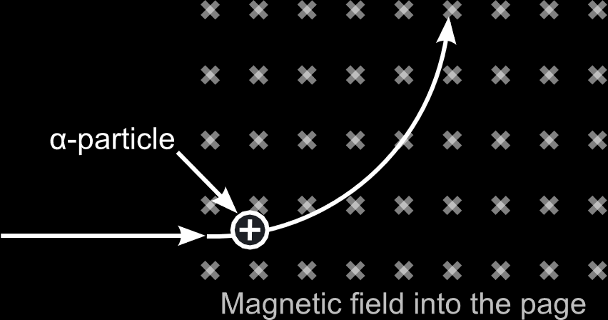

Nothing happens for electromagnetic radiation

$α$ particle is deflected upwards

$β$ particle is deflected downwards

Light is undeviated

### Oscilloscope

* shows electromagnetic wave patterns



If both signals together, parabolic path, Lissajous figures

$$y=Asin(ωt+ϕ)$$

$y=\frac{1}{2}gt^{2}$ $→$ example

$$F=qE$$

1. Fluorescence
2. Photoluminescence
3. Electroluminescence
4. Cathodoluminescence

Electric field ($\overline{E}$)

1. $\vec{E}=\frac{1}{4πϵ_{0}}\frac{q}{r^{2}}$ (vector)
2. $\vec{F}=\frac{1}{4πϵ_{0}}\frac{q^{2}}{r^{2}}$ (vector)

$V=\frac{1}{4πϵ_{0}}\frac{q}{r}$

$$-\frac{δv}{δr}=\vec{E}$$

$$-\int{\overline{E}⋅δr}=V$$

$V$ is a macro quantity (can be measured)

$E$ is a micro quantity (cannot be measured)

$$F=qE$$

$$F=ma$$

$\vec{a}=\frac{qE}{m}$

The acceleration of the electron can be found using this equation.

### Gauss’s Law

$ΦE=\overline{E}. \overline{ds}$ Electric Flux

$ΦB=\overline{B}. \overline{ds}$ Magnetic Flux

- integration in closed area

Example 1:



charge density $=λ$

$$ϵ_{0}\oint{\vec{E}⋅\vec{ds}}=q_{net}$$

$ϵ_{0}E\oint{\vec{ds}}=q_{net}$ since $E$ is constant

$$ϵ_{0}E⋅2πyl=λl$$

$$E=\frac{λ}{2πϵ_{0}y}$$

Example 2:



$σ$– surface charge density

$$ϵ_{0}\oint{\vec{E}⋅\vec{ds}}=q_{net}$$

$$ϵ_{0}E\oint{\vec{ds}}=σA$$

$$E=\frac{σA}{2Aϵ_{0}}$$

$$E=\frac{σ}{2ϵ_{0}}$$